AI Cloud Security Environment Setup

1 Environment Setup
We developed a visual, interactive, and extensible experimental dashboard based on Python and Streamlit to evaluate the proposed AI-driven cloud security framework for SIEM event management and policy optimization. The dashboard is designed for non-cybersecurity professionals in SMEs and healthcare institutions, and it simulates attack detection, log visualization, geographic source mapping, and AI-driven risk inference.

1.1 Experimental Platform Overview
The experimental dashboard provides:
- Real-time attack trend visualization
- Geographic heatmap of source IPs
- Distribution of attack types and risk levels
- Simulated LLM-driven explainable threat classification
- Data filtering and CSV export for further analysis
The dashboard mimics a realistic cloud monitoring environment with future support for GPT-based SIEM log interpretation.

1.2 Software and Dependency Environment

Component | Description
Operating System | Windows | Mac OS | Linux
Python Version | Python 3.8 or Later
Environment Tool | Venv( recommended for isolation)
Required Packages | Streamlit, pandas, plotly, matplotib

1.3 Project Structure
The project contains the following files:
- ai_intrusion_dashboard_refined.py: Streamlit dashboard script
- attack_log_dataset.csv: Experiment log dataset with 11 attack types
- README_AI_Cloud_Security_Dashboard.txt: Setup and usage guide

1.4 Execution Steps
1. Install Python and create a virtual environment (optional)
2. Install dependencies:
pip install streamlit pandas plotly matplotlib
3. Run the dashboard:
streamlit run ai_intrusion_dashboard_refined.py
4. The dashboard will open at http://localhost:8501

1.5 Dashboard Screenshot
The figure below shows the main interface of the dashboard.
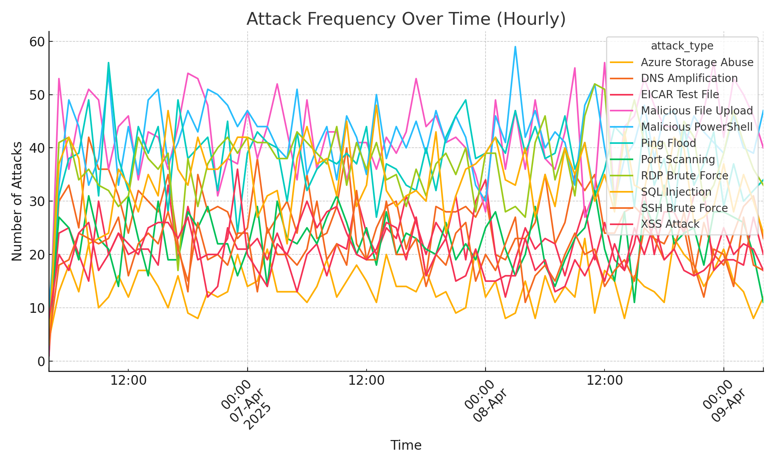
Figure 5.1.1 - Attack trend over time as displayed in the dashboard.

